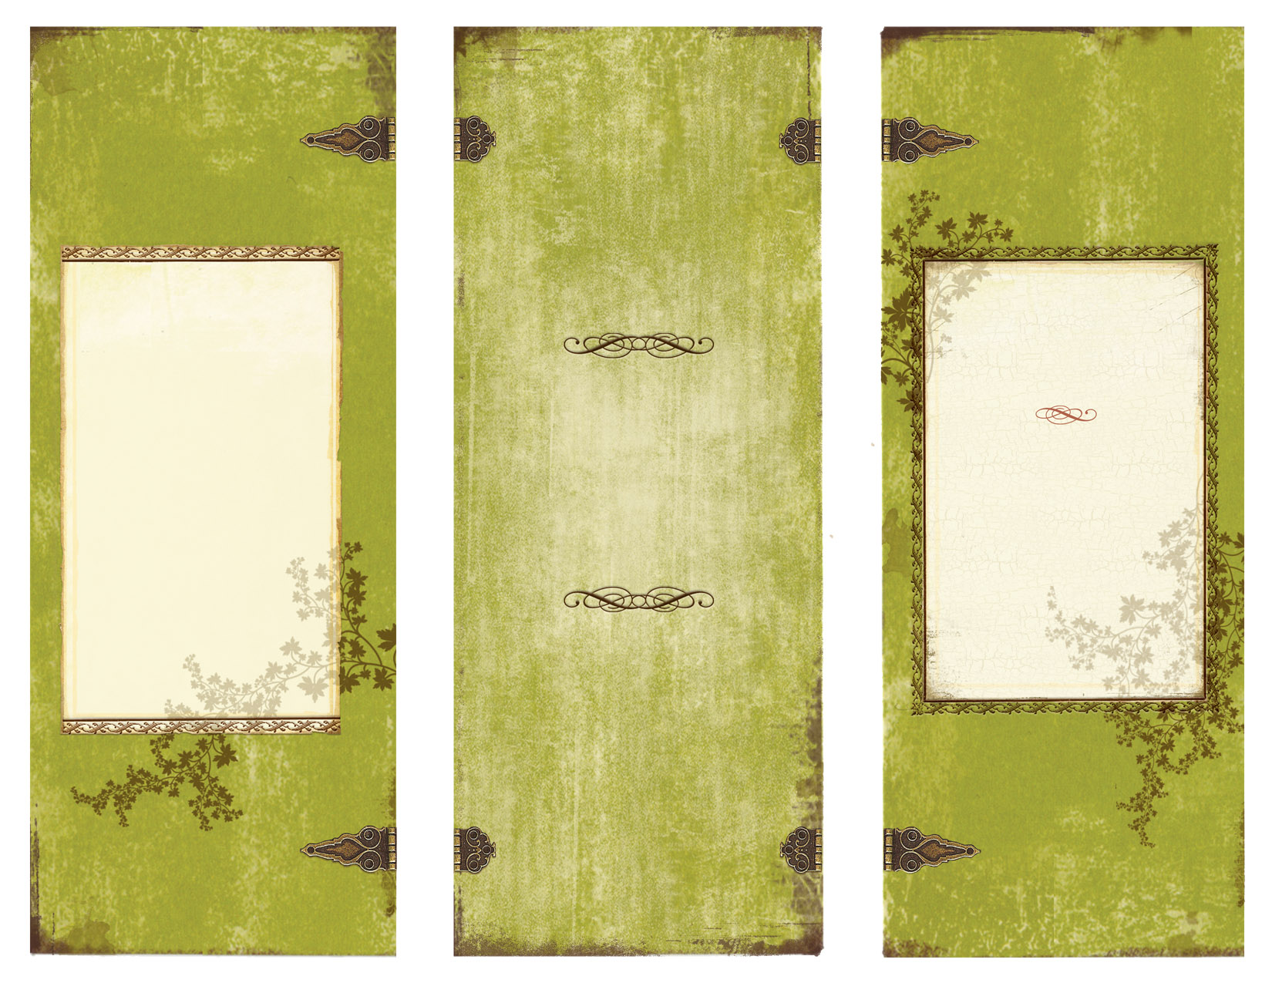

credmond@penketh.warrington.sch.uk

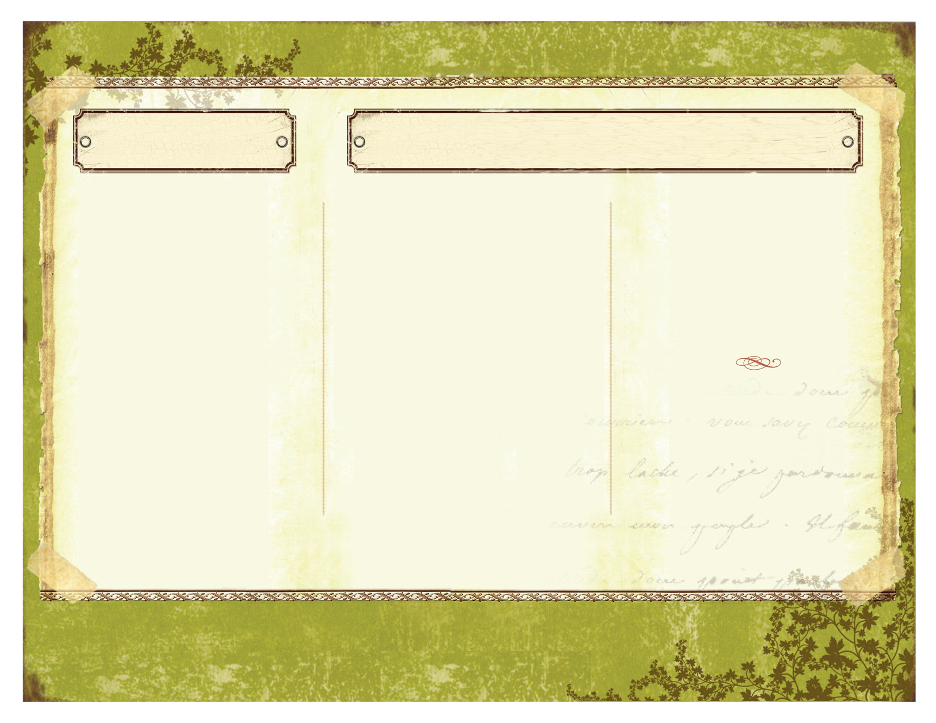

**We accept all methods of homework**

**payment including:**

**Paper**

**Email**

**Any three dimensional creation**

Please select a three course meal from the menu to complete for your homework this term.

You can complete as many pieces of homework as you wish, but you MUST hand in a starter, main course, desert and side order for the deadline given.

Bon Appetit!

MC900238643[1]

MISS REDMOND

Y9

TAKEAWAY MENU

MENU GUIDE

• Create a quiz of 10 questions that the class could complete following what we have learned during this term. You can create this on a sheet of paper or online using Survey Monkey.

• Write down five key words from the topic we have covered this term. Write out the definition and examples that a student could use as a help guide.

• Create a character profile with quotation analysis and thought bubbles to demonstrate your analysis.

MAIN COURSES SIDE ORDERS AND DESSERTS

STARTERS

Please select a starter, main course and dessert to complete. Side orders are not optional.

Create a ‘Take a Break’ style magazine about moments within the play. Consider the relationship between the characters.

  Create a three dimensional scene from the play. Include quotations with analysis to demonstrate your understanding.

  Produce a storybook that re-tells the story of the play in a different setting. This could simply be in the modern day, or a time/setting of your choice. Use quotations from the play and translate to your own to help you tell the story.

 SIDE ORDERS

**Research sixteenth century Italy. You should include the art, literature, and information about Messina, where the play is set.**

**Research the role of women in the 16th Century, how does it differ to how women act and behave in modern times?**

DESSERTS

· Explore how the play challenges gender stereotypes.. You can choose how you present this.

· Write a review of the film, comparing your experience in contrast to the play.

· Create a film set for your own production of Much Ado about Nothing. Select your cast, soundtrack and costume design.