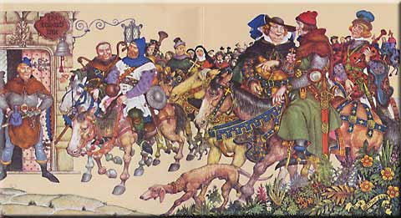
The pilgrims prepare to make their journey to Canterbury from London.... but why?

Your task is to find out about Thomas Becket and why his shrine at Canterbury was such a popular place of pilgrimage until the early 1500s. As you gather information, focus on the following questions:
- What are the main facts surrounding Becket’s life and death?
- Why was pilgrimage important during the Middle Ages?
- Why would pilgrims have gone to visit Becket’s shrine at Canterbury?
- What type of people would have gone on the pilgrimages?
- What other important pilgrimage routes/places were there in Britain and Europe?
- What was life usually like for the people on a pilgrimage?
Make clear notes on what you discover!
Once you have answered all of the questions above, your final task is to create a small booklet or leaflet explaining why pilgrims would travel to Canterbury to visit the shrine of Thomas Becket. You will be assessed on the following criteria:
Reading: AF2 – ability to select information using research
Writing: AF3 – ability to organise and present information effectively

If you are struggling, try doing a Google search using the following terms:
‘Thomas Beckett’
‘Canterbury Cathedral’
‘Pilgrim’
‘Pilgrimage’

Task 2:
Research the history of your surname (or of a famous person).
Make notes and try and find a surname coat of arms:
For example: Redmond
Origin: Irish
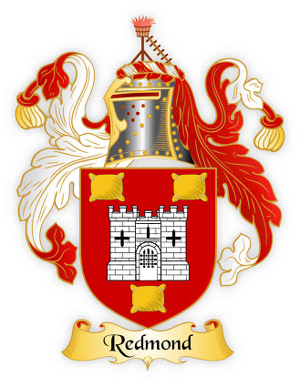
Spelling variations of this family name include: Redmond, Reddman, Reddmon, Redman, Reddan, Redmon, Redmand, Readmond, Redmaynd, Redmayne, Reddmayne, Redmane, Reddmane, Reddane, Redmoyne, Redmoynd, Redmain, Redmaine, Redmoine, Reddmyne, Redmyn, Reddmin, Redmin, Redmind and many more. First found in county Wexford where they were granted lands by Strongbow, Earl of Pembroke, during the invasion of Ireland in 1172. Some of the first settlers of this family name or some of its variants were: Thomas Redman settled in Barbados in 1635; William Redman settled in Virginia in 1636; Mary Redman settled in Virginia with her husband in 1652; Patrick Redmond settled with his wife Bridget and four children in New York State in 1804.
Crest: A beacon fired.
Coat of arms: Red with a silver castle between three gold cushions.
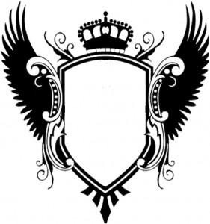
Coats of Arms are old and your task is to modernise the one you have researched. What things would go in it e.g. is your family obsessed with football?

Task 3
My Language.
1. Where were you born?
2. Where have you lived?
3.Which schools have you attended and how many languages were spoken there, give some examples of words and phrases you learned from other students (don’t be rude!)
4. Can you remember any books that helped your vocabulary; certain words you use now that you heard/read. Eg. The School Dormitory from Harry Potter etc.
5. Are there certain words you mis-spell because of the way you pronounce them!
- Havin a larf
- There’s nufink left
-I could of hurted him
6. Your favourite modern words: text language, roflcopter, jel(ous), totes (totally) etc.
Task 4:
A Brief History of the English Language.
1. Draw a time-line of the main historical events that influenced the English Language
2. Draw an invasion map showing who invaded England and when?

Useful Resources
These two below are really useful websites on how the English language is evolving. Google :
1. map your voice British Library ( click on the world map)
2. Bbc.co.uk/voices (play the game ‘Wordly Wise’; click on ‘Voices- Recordings’)
- Dictionaries, newspapers, books, your English book.
- Use these to find definitions and examples of jargon.

